Lab Exercise 1- Working with Git Revert
Lab Exercise: Git Revert
This exercise will guide you through reverting changes in Git. The git revert command is used to create a new commit that undoes the changes introduced by a previous commit without modifying the history.

Objective
- Learn how to use git revert to undo changes from specific commits.
- Practice handling merge conflicts during a revert.

Prerequisites
- Install Git on your system.
- Set up a Git repository:
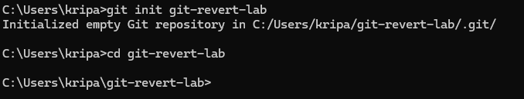

Steps
1. Set Up the Repository
- Create a file:
- Stage and commit the file:
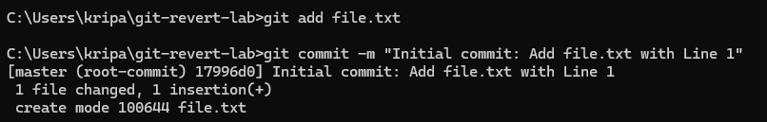
- Add more changes:
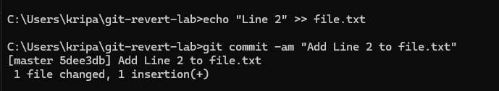
- Add another change:
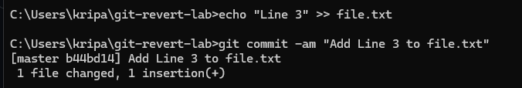
- Verify the commit history:
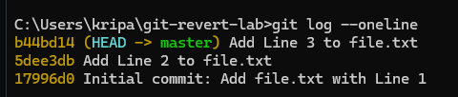

2. Revert the Last Commit
- Revert the most recent commit:
- Git will open a text editor for the commit message. Save and close the editor to complete the revert.
- Verify the contents of file.txt:
cat file.txt
Output:
Line 1
Line 2

- Check the commit history:
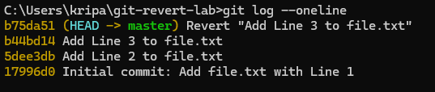

3. Handle Merge Conflicts During Revert
- Modify file.txt:
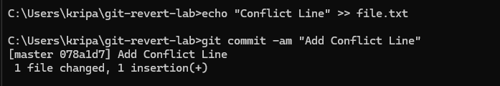
- Revert the second commit (8b2a1c1 again) to trigger a conflict:
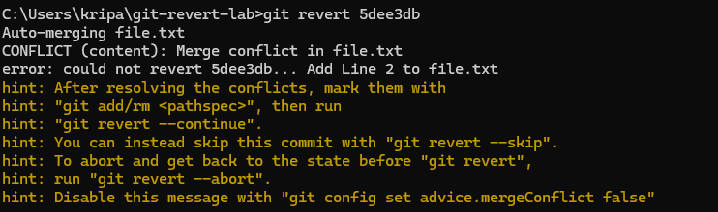
- Git will indicate a conflict. Resolve it:
  - Open file.txt and remove conflict markers.
  - Keep the desired lines.
- Stage the resolved file:
- Complete the revert:
